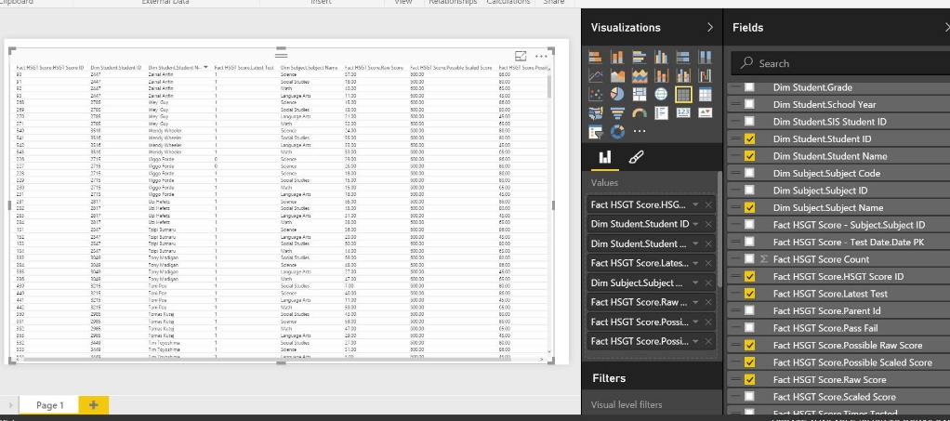--Performance

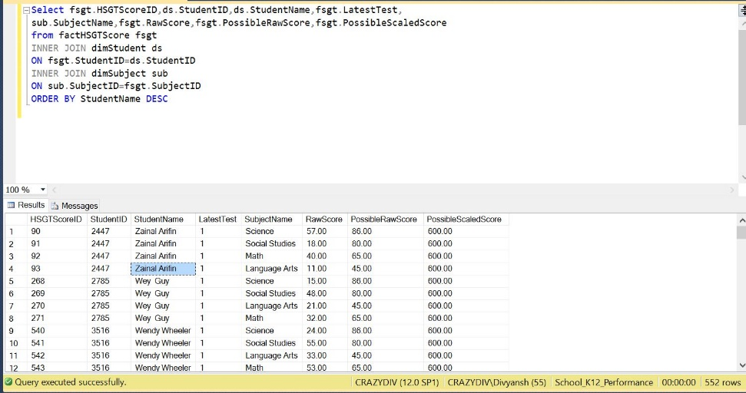

--Number of distinct Students in each subject

Select c.SubjectID,c.SubjectName ,count(distinct a.StudentID) AS StudentCount

FROM

factStudentCourse a

JOIN

dimCourse b

ON a.CourseID = b.CourseID

JOIN

dimSubject c

ON

b.SubjectID = c.SubjectID

WHERE c.SubjectID in (10,14,15,9)

group by c.SubjectID,c.SubjectName;



